If that box collider belongs to an “enemy”. Then these if statements are run.  
First, checking if the character is in its falling state, so then we can kill it.

This method is called every time the character’s sprite collides with another box collider.

If the character is not in the falling state, then it has been hit, so the player gets knocked back a little bit either left or right, depending on which way the enemy was facing.

These are the unity functions that I called, like the box collider and animator.

This controls how double jumping works and was added into for the final iteration of the movement script.

It would allow only one extra jump when the character is in the air, then it would require the character to collide with the floor to jump again.

This also controls the animation of double jump, which is not part of the finite state machine. This toggles a Boolean true or false depending on if the character can double jump.

This is the Movement() method.   
This code does not differ far from the second iteration of my code. The only real change here is how and when my animations were played. This was moved to another method.

These were variables that I could edit whilst testing the game, so increasing or decreasing the player speed.

This is the finite state machine, which controlled all but one of my character animations

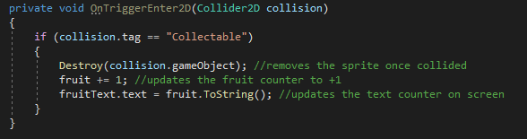

The method gets called every time a collision between box colliders occurs.  
It then checks if it is a “collectable” item, this is done by checking the tag.  
If it matches, then the fruit is “destroyed” and the fruit counter is updated along with the UI on screen counter.

Further explanation of this method will be talked about in the “explanation of the code”.

This is the AnimationState() method, this method controls all the animations the character shows on screen.

Most of this code was annotated directly, which explains what each line does.